

**MEE 306**

**DESIGN OF TRANSMISSION SYSTEMS PROJECT ON**

**DESIGN OF FNR GEARBOX**

**Team Members:**

B. Shiv Ram Krishna – 10BME 1029

Yash Ganatra – 10BME1043

Sachin Kishore – 10BME 1087

Surojit Dey – 10BME 1102

1. **ABSTRACT:**

In this Project “DESIGN AND ANALYSIS OF FNR GEARBOX” mainly focuses on the mechanical design and analysis of Gearbox as transmit the power. We have developed this work with a view to get familiar with the technologies as well as application of theories into practical work.

This project contains the design and material selection of the gearbox for

A rear engine “ALL TERRIAN VEHICLE” which will have only forward neutral and reverse gears for better efficiency, improvement of Power transmit rate is important phenomenon.

1. **INTRODUCTION**

Gearboxes are used in almost every industry right from power to marine, and also include agriculture, textile, automobiles, aerospace, shipping etc. There are different types of gearboxes available for varying uses. These gearboxes are constructed from a variety of materials depending on their end use and the kind of industry they are being used in. The product has numerous industrial applications for providing high torque and smooth speed reductions. These gearboxes are also manufactured keeping certain specifications in mind, which will also vary depending on the application.

In this project we have considered a All-terrain vehicle which has its engine in its rear position and have a CVT attached to it. As CVT is attached multiple gear ratios are not required in the gear box. So a gearbox having a forward, neutral and a reverse gear will be sufficient in this case.

A Helical Gear has tooth in the form of helix wound around the gear. The pitch surfaces are cylindrical but the teeth wind around the cylinders helically. This provides continuous and gradual engagement of the teeth resulting in a smoother drive with a high transmission efficiency.

1. **LITERATURE REVIEW**

**3.1 KINEMATICS**

Helical gear can be thought of as an ordinary spur gear machined from a stack of thin shim stock, each limitation of which is rotated slightly with respect to its neighbours.



FIGURE 1: PARALLEL BETWEEN HELICAL AND SPUR GEARS

The shape of the tooth is an involute helicoid as illustrated in the Fig. 11.8. If a paper piece of the shape of a parallelogram is wrapped around a cylinder, the angular edge of the paper becomes the helix. If the paper is unwound, each point on the angular edge generates an involute curve. The surface got when every point on the edge generates an involute is called involute helicoid. In spur gear, the initial contact line extends all the way across the tooth face. The initial contact of helical gear teeth is point which changes into a line as the teeth come into more engagement.

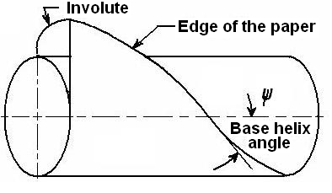

FIGURE 2: FORMATION OF HELICAL GEAR TOOTH

# MATERIAL SELECTION:

A range of gearboxes are constructed from a variety of materials depending on the industry or the product in which they are being used for. Finest quality materials are used to manufacture gearboxes for ensuring reliability, ease of maintenance and long life. The specialty gearboxes materials undergo vibration and endurance test to ensure that the end product is of premium quality.

* Aluminum Gearbox
* Cast Iron Gearbox
* Bronze Iron Gearbox
* Stainless steel Gearbox

Casing is made of Aluminium as it is lighter yet sturdy.

* 1. **FORCE ANALYSIS**



FIGURE 3: COMPONENTS OF FORCE

**Fr = Fn sin Øn………………. (1)**

**Ft = Fn cos Øn cos ψ………... (2)**

**Fa = Fn cos Øn sin ψ…………(3)**

**Fr = Ft tan Ø …………………(4)**

**Fa = Ft tan ψ …………………(5)**

1. **OBJECTIVES**

* The present study involves design and analysis of spur gear according to Lewis Bending Theory which states that at a given point of time maximum load acts on single tooth. The tooth acts as a cantilever beam.
* Validation of the theory is done by analysis on.

1. **PROBLEM SPECIFICATION**

* **Power Transmitted = 7.5 kW**
* **Transmission Ratio = 2.7 * 3.3**
* **Pinion rpm = 3600**
* **Material : ALLOY STEEL**
* **Helix Angle: 15˚**
* **Normal Pressure Angle: 20˚**
* **Normal Module : 3mm (Computed from theory)**
* **Load on a tooth = 10 383 N (calculated from eqn 2)**
* **Yield Strength = 620 MPa**

1. **GEAR TRAIN ASSEMMBLY:**

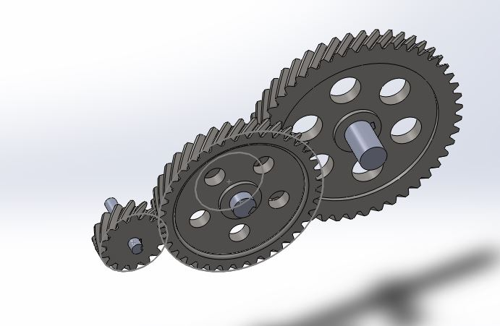

Figure 1: Gear Train Modelled in SolidWorks

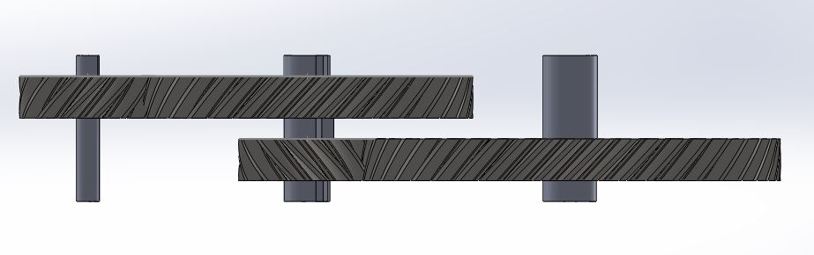

Figure 2: Plan of the Assembly

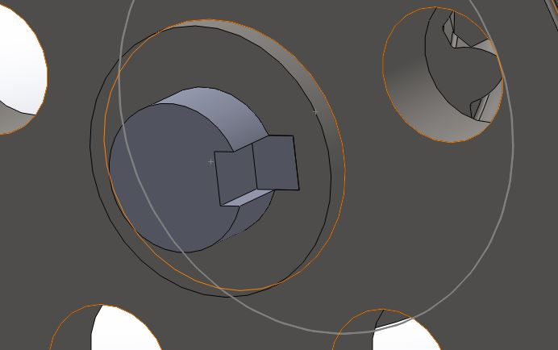

Figure 3: Key used to constrain the gear

1. **VALIDATION OF RESULTS**

The Gear Design Principles learnt in Design of Transmission Systems have been applied. PSG Design Data Book has been used as the reference.

**MATERIAL PROPERTIES:**

* Ϭy = 88 Kgf/mm2
* Ϭy = 1760 N/mm2

**ALLOWABLE BENDING STRESS:**

[Ϭb]=

* n =2.5
* Kb1 =0.7
* KϬ = 1.5
* Ϭ-1 = (0.35u) + (1200) = 7360 Kgf / cm2
* [Ϭb] = 192.341 N/mm2

**ALLOWABLE COMPRESSIVE STRESS:**

* [Ϭc] = CR*HRC*Kc1 = 852.6 N/mm2
* CR = 265
* Kc1 = 0.585
* [Ϭc] = 852.6 N/mm2

**CENTRE DISTANCE:**

* a ≥ (i+1) $\sqrt[3]{\left(\frac{0.7}{\left[Ϭc\right]*[Ϭc]}\right)\left(\frac{Ex[Mt]}{iΨ}\right)}$
* [Mt] = Mt*K*Kd
* K*Kd =1.3
* Mt = 2087.57 N-mm
* Ex  = 207 * 109 Pa
* = 0.5 (assumed)
* ≥ 154.44 = 155 mm
* Z1 = 20
* Z2 = 85
* Mn = = 2.85 = 3 mm
* Revised centre to centre distance:

a = $\frac{Mn*(\left(Z1\right)+\left(Z2\right))}{Cos β}$ = 163.055 mm

d1 = = 62.164 mm

d2 = = 263.995 mm

**REVISED TWISTING MOMENT:**

* b = Ψ*a = 81.5275 mm
* Ψp = = 1.3124
* K = 1.165
* V = $\frac{¶dn}{d160}$ = 5.6917 m/s
* Kd = 1.2
* [Mt] = Mt*K*Kd = 3066.77 * 102 N-mm

**INDUCED BENDING STRESS:**

* Ϭb = 0.7 $(\frac{i+1}{ ab(Mn)(Yv)}$*) = 70.25 Mpa < [Ϭb]
* Zv = = 22.192
* Form Factor (Yv) = 0.402

**INDUCED BENDING STRESS:**

Ϭc = 0.7 $(\frac{i+1}{a})$ $\sqrt[2]{\left(\frac{i+1}{ib}\right)\left(\frac{E[Mt]}{1}\right)}$

**

Ϭc = 698.7 Mpa < [Ϭc]

* **SHAFT SELECTION:**

Designing the shaft for shear, the diameter is found to be 26 mm, 22mm and 11mm

* **BEARING SELECTION**

Since axial load is applied, angular contact ball bearing used. (e=1.14)

$$Fr=BM x\frac{L}{4}=2440 N$$

Where BM is the Bending Moment

$$\frac{Fa}{Fr}=0.238 <e$$

$$X=1, Y=0$$

$$Pe=XVFr+YFe$$

$$Pe=3660 N$$

$$C=P x L^{1/k}$$

$$C=4880 N$$

Bearing Number = 3308

1. **REFERENCES:**

* Khurmi R.S., Design of Machine Elements, S.Chand Publications,2012
* Shighley Joseph, Mechanical Engineering Design, Mcgraw Hill Publications, 2012
* Solidworks Manual - 2012